**4.1 Socio-demographic characteristics**

In this study, the mean age was 24.8 years, as the lowest age was 18 years, maximum age was 57 years and modal age group (50.4%) was the 20-29years age group. Majority of the respondents were female (72%), Yoruba (85%), single (86%), Christian (56%). Most of them had secondary level education (76%), where about half of them claimed their father (54%) and mother (54%) had secondary level education. As regard their family and financial strength, majority had monogamous family (65%), large family (63%), two siblings with sickle cell disease (73%), earn average income of ₦ 137,430- ₦200,000 (98.4%), and financing their healthcare by themselves (92%). Figure 4.1a shows an age-sex pyramid where there are more female across all the age categories.

Clinical history of the participants showed that majority had the HbSS type of SCD (86%). Only few (34%) of the participants knew their steady PCV, where the median and Inter-quartile PCV was 26% (22.5%, 28.0%), most of them (86%) claimed they last checked their PCV 1-2 years ago and the median PCV (IQR) when last checked was 24% (20%, 28%). Most of the participants (67%) had one crisis in the past 6 months, where many of them (34.1%) specify crises associated with bone pain as the most common. Many participants claimed they have had zero hospital admission (64%), zero blood transfusion episode (82%), zero visits for chronic pain (54%). Few participants (13%) had comorbidities, where anaemia accounts for majority (31.2%) of the reported comorbidities. Less than half of the participants (41.5%) claimed they had complications, such as neuropathy (33%), neuropathy and chronic ulcer (19.6%), chronic ulcer (13.7%), see Figure 4.1b.

**Table 4.1 Socio-demographic characteristics**

| **Characteristic** | **N = 123** |
| --- | --- |
| **Mean Age (range)** | 24.8 ± 7.6 (18, 57) |
| **Age group** |  |
| 10-19years | 33 (27%) |
| 20-29years | 62 (50.4%) |
| 30-39years | 22 (17.8%) |
| 40-49years | 3 (2.4%) |
| 50-59years | 3 (2.4%) |
| **Gender** |  |
| Female | 89 (72%) |
| Male | 34 (28%) |
| **Ethnicity** |  |
| Ibo | 14 (11%) |
| Others | 5 (4%) |
| Yoruba | 104 (85%) |
| **Marital status** |  |
| Married | 12 (9.8%) |
| Separated | 5 (4.2%) |
| Single | 106 (86%) |
| **Religion** |  |
| Christianity | 69 (56%) |
| Islam | 54 (44%) |
| **Education level** |  |
| Primary | 7 (6%) |
| Secondary | 82 (76%) |
| Tertiary | 19 (18%) |
| Missing | 15 |
| **Education level of father** |  |
| Primary | 14 (12%) |
| Secondary | 67 (54%) |
| Tertiary | 42 (34%) |
| **Education level of mother** |  |
| Primary | 20 (16%) |
| Secondary | 66 (54%) |
| Tertiary | 37 (30%) |
| **Family type** |  |
| Monogamous | 80 (65%) |
| Polygamous | 43 (35%) |
| **Family size** |  |
| Small | 45 (37%) |
| Large | 78 (63%) |
| **Number of sibling with sickle cell disease** |  |
| 1 | 33 (27%) |
| 2 | 90 (73%) |
| **Average Income (National Bureau of Statistics, Nigeria)** |  |
| Poverty line (₦137,430 - 350,000) | 121 (98.4%) |
| 1k-10k (₦ 200,000 – 500,000) | 2 (1.6%) |
| **Source of healthcare financing** |  |
| HMO | 10 (8%) |
| Self | 113 (92%) |

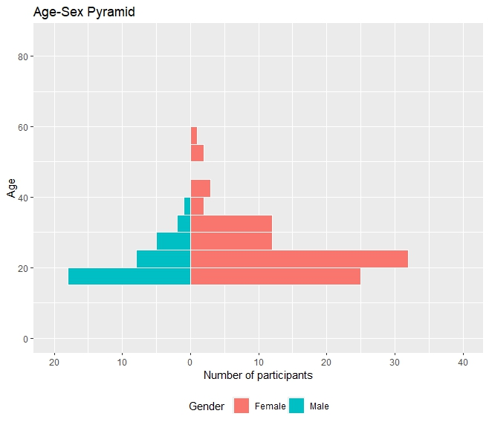

Figure 4.1a Age-sex pyramid of the participants in this study

Table 4.1.2 Clinical history of the participants

| **Characteristic** | **N = 123** |
| --- | --- |
| **Type of Sickle cell disease** |  |
| HbSC | 17 (14%) |
| HbSS | 106 (86%) |
| **Knowledge of steady PCV (Yes)** | 39 (34%) |
| **Medan PCV (IQR)** | 26.0 (22.5, 28.0) |
| **Last time PCV was checked** |  |
| <1 year ago | 3 (5.1%) |
| >5 years ago | 3 (5.1%) |
| 1-2 years ago | 51 (86.4%) |
| 2-5 years ago | 2 (3.4%) |
| Unknown | 64 |
| **Median value of last PCV (IQR)** | 24.0 (20.0, 28.0) |
| Unknown | 69 |
| **Number of crisis in past 6 months** |  |
| 1 | 83 (67%) |
| 2 | 40 (33%) |
| **Do you know the type of crises (Yes)** | 56 (46%) |
| **Type of crises as specified by participants** |  |
| Haemolytic | 4 (7.2%) |
| Vaso-occlusive | 52 (92.8%) |
| **Number of hospital admission** |  |
| 0 | 79 (64%) |
| 1 | 44 (36%) |
| **Number of blood transfusion** |  |
| 0 | 101 (82%) |
| 1 | 22 (18%) |
| **No of visits for chronic pain** |  |
| 0 | 66 (54%) |
| 1 | 57 (46%) |
| **Presence of complication (Yes)** | 51 (41.5%) |
| **Presence of co-morbidities (Yes)** | 16 (13%) |
| **Co-morbidities participants** |  |
| Anaemia | 5(31.2%) |
| Osteopathic condition | 2(12.5%) |
| Chest pain | 2(12.5%) |
| Hearing loss | 1(6.3%) |
| Peptic ulcer disease | 3(18.7%) |
| Leg ulcer | 1(6.3%) |
| Ocular conditions (cataract) | 2 (12.5) |
| **Presence of complication (Yes)** | 51 (41.5%) |

Figure 4.1b Presence of complications among participants

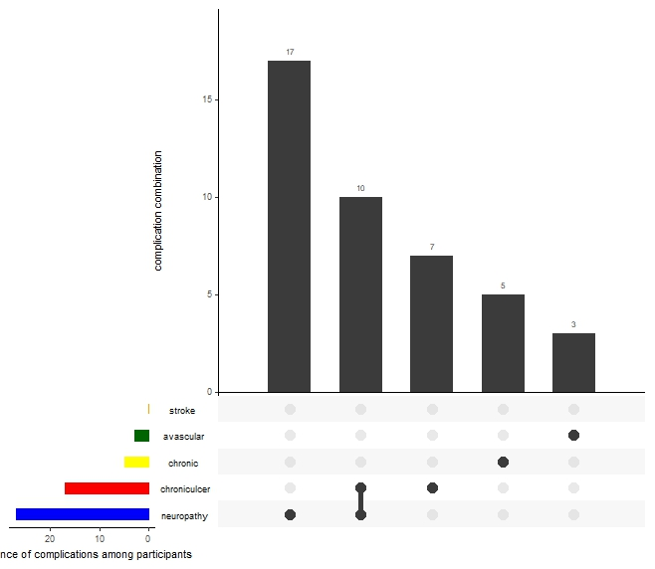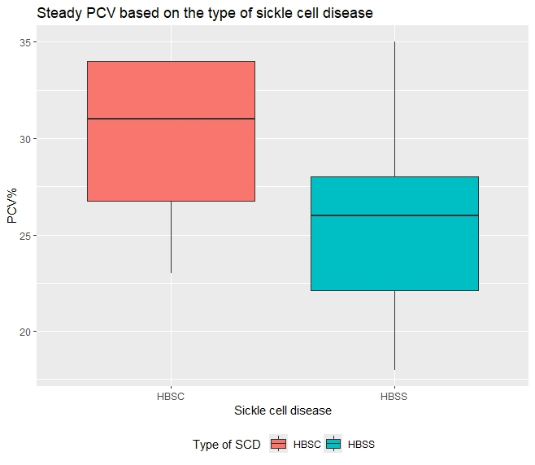

Figure 4.1c Boxplot showing PCV level among HbSC and HBSS

**4.2 Prevalence of Depression Among Participants**

The severity and prevalence of depression was assessed using the PHQ-9 instrument, the reliability statistics of this instrument was very high in this study (Cronbach a = 0.785) see Appendix I. PHQ-9 presents the severity of depression based on the following scores: 0-5 (none-minimal), 5-9 (mild depression), 10-14 (moderate), 15-19 (moderately severe), 20-27 (severe). In this study, the severity of the depression is as follows: None (28.5%), Mild (30.9%), Moderate (26%), Moderately severe (9.8%) and Severe (4.9%). Figure 4.2b presents the distribution of sickle cell diseases according to the depression categories, it shows that the greatest proportion (50%) of HbSC participants had severe depression whereas, the greatest proportion (92.1%) of the HbSS participants had mild depression. Based on the PHQ-9 scoring, any participant scoring ≤ 5 is considered not depressed, while any participant scoring ≥ 6 is considered depressed. Therefore, the prevalence of depression in this study is 71.5%

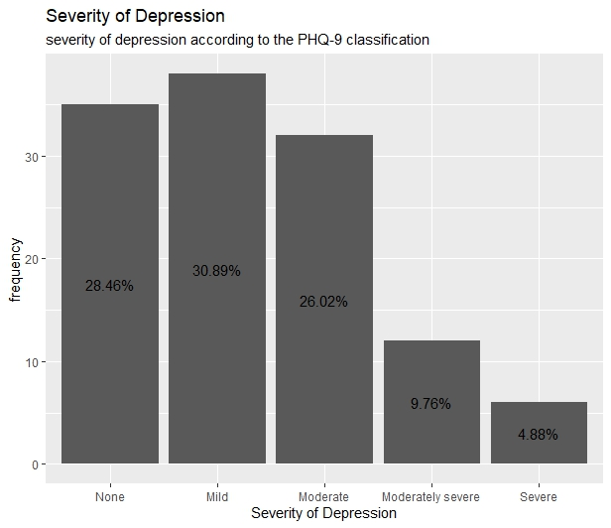

Figure 4.2a Prevalence of Depression in this study

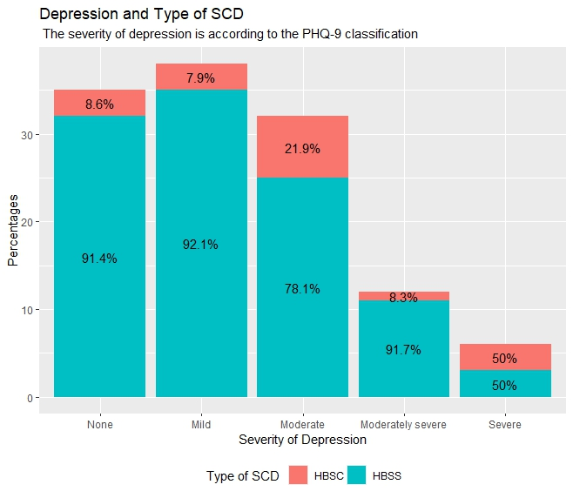

Figure 4.2b The distribution of sickle cell diseases according to the different depression categories.

**4.3 Health-related Quality of Life of the participants**

The health-related quality of life of the participants were assessed using the short-form 36, the reliability statistics of this instrument was very high in this study (Cronbach a = 0.801) see Appendix II. The 36-item questions were recoded as score as shown in Table 4.3.1, before regrouping them into 8 domains as follows: physical functioning PF, role functioning/physical RP, role functioning/emotional RE, energy/fatigue EF, emotional well-being EWB, social functioning SF, pain and general health GH. These 8 domains were categorized into physical component (PF, RP, PAIN and GF) and mental health components (RE, EF, EWB and SF).

Table 4.3.2 presents the essential summary statistics of the 8 domains and the 2 health related quality of life components, it comprises of the minimum value, maximum value, median, interquartile range, mean, standard deviation and standard error. The mean ± S.D of the 8 domains are as follows: PF (69.153 ± 24.458), RP (46.545±41.529), RE (52.575±45.570), EF (47.276±14.160), EWB (45.789±16.597), SF (44.512±20.254), pain (36.419±28.887) and GH (42.967±14.241). As for the components, both the physical (48.771±14.617) and mental (47.538±13.525) components recorded mean ± SD score within 40-60 which might suggest below average to slightly above average quality of life, where average quality of life is 50.

The Shapiro-Wilk Normality test is used to check if a set of continuous data has a normal distribution or skewed distribution. Taking its level of significance at p-value <0.05, any distribution with a p-value < 0.05 is considered skewed and not in a normal distribution. Table 4.3.3 shows that both MCS and PCS are not normally distributed at p-value of 0.045 and 0.004 respectively. The implication of this is that non-parametric equivalents will be used when performing inferential test on the two parameters.

Table 4.3.1 SF-36 Recoding and scoring table

|  |  |
| --- | --- |
| Question number | Original response→ recoded value |
| 1, 2, 20, 22, 34, 36 | 1 → 100  2 → 75  3 → 50  4 → 25  5 → 0 |
| 3, 4, 5, 6, 7, 8, 9, 10, 11, 12 | 1 → 0  2 → 50  3 → 100 |
| 13, 14, 15, 16, 17, 18, 19 | 1 → 100  2 → 80  3 → 60  4 → 40  5 → 20  6 → 0 |
| 24, 25, 28, 29, 31 | 1 → 0  2 → 20  3 → 40  4 → 60  5 → 80  6 → 100 |
| 32, 33, 35 | 1 → 0  2 → 25  3 → 50  4 → 75  5 → 100 |

Table 4.3.2 Descriptive statistics of the domains and components of the Short form-36

| variable | n | min | max | median | IQR | mean | s.d | s.e |
| --- | --- | --- | --- | --- | --- | --- | --- | --- |
| PF | 123 | 0.000 | 100.00 | 75.000 | 35.000 | 69.153 | 24.458 | 2.205 |
| RP | 123 | 0.000 | 100.00 | 25.000 | 100.000 | 46.545 | 41.529 | 3.745 |
| RE | 123 | 0.000 | 100.00 | 66.667 | 100.000 | 52.575 | 45.570 | 4.109 |
| EF | 123 | 10.000 | 100.00 | 50.000 | 15.000 | 47.276 | 14.160 | 1.277 |
| EWB | 123 | 0.000 | 100.00 | 48.000 | 24.000 | 45.789 | 16.597 | 1.497 |
| SF | 123 | 0.000 | 100.00 | 50.000 | 12.500 | 44.512 | 20.254 | 1.826 |
| PAIN | 123 | 10.000 | 100.00 | 32.500 | 54.750 | 36.419 | 28.887 | 2.605 |
| GH | 123 | 10.000 | 75.00 | 45.000 | 15.000 | 42.967 | 14.241 | 1.284 |
| PCS | 123 | 18.250 | 86.25 | 50.625 | 18.188 | 48.771 | 14.617 | 1.318 |
| MCS | 123 | 13.125 | 75.00 | 47.750 | 21.750 | 47.538 | 13.525 | 1.220 |

n = number of samples, IQR = Interquartile range, s.d = standard deviation, s.e = standard error

Table 4.3.3 Shapiro-Wilk Normality test of the physical and mental components

| variable | statistic | p-value |
| --- | --- | --- |
| MCS | 0.9783708 | 0.045393977 |
| PCS | 0.9665474 | 0.003797518 |

**4.4.1 Predictors of Health Related Quality of Life HR-QOL (Physical components)**

This study employed the use of the chi-square test of association to determine the significant associations between variables and the quality of life at significant p-value of 0.05. As for the physical components, gender (chi-square = 3.584, p-value =0.045), type of sickle cell disease (chi-square = 4.044, p-value = 0.044) and number of blood transfusion episode <1yr (chi-square = 4.597, p-value = 0.032) were statistically significant associated with quality of life. For mental health components, education level (chi-square = 7.441 p-value = 0.024) and number of blood transfusion episode <1yr (chi-square = 3.880, p-value = 0.042) were statistically significant associated with quality of life.

Multinomial logistic regression was used to examine the predictors of below average HR-QOL, while taking significant level at p-value < 0.05. The male gender ([OR] = 2.168, p-value = 0.061, [AOR] = 2.164, p-value = 0.071) was 2.2 times more likely to have below average physical HR-QOL than the female gender. The HbSS participants ([OR] = 0.332, p-value = 0.042, [AOR] = 0.337, p-value = 0.050) were 0.33 times less likely to have below average physical HR-QOL than the HbSC. Participants who had 0 number of blood transfusion episode (OR] = 2.944, p-value = 0.037, [AOR] = 2.790, p-value = 0.048) were 2.8 times more likely to have below average physical HR-QOL than those that had one transfusion episode.

As for the predictors of below average mental HR-QOL, secondary level of education ([OR] = 3.960, p-value = 0.012, [AOR] = 4.425, p-value = 0.007) were 4.4 times significantly likely to have below average mental HR-QOL. Meanwhile, participants who had 0 number of blood transfusion episode (OR] = 2.561, p-value = 0.054, [AOR] = 2.226, p-value = 0.168) were 2.2 times more likely to have below average mental HR-QOL than those that had one transfusion episode.

Table 4.4.1 Predictors of Health Related Quality of Life (Physical components)

| Sociodemographic Characteristic | Below Average | Above Average | Chi-square | P-value |
| --- | --- | --- | --- | --- |
| **Age category** |  |  | 3.910 | 0.428 |
| 10-19years | 15 (45.5%) | 18 (54.5%) |  |  |
| 20-29years | 33 (53.2%) | 29 (46.8%) |  |  |
| 30-39years | 7 (31.8%) | 15 (68.2) |  |  |
| 50-59years | 2 (66.7%) | 1 (33.3%) |  |  |
| **Gender** |  |  | 3.584 | 0.045&* |
| Female | 38 (42.7%) | 51 (57.3%) |  |  |
| Male | 21 (61.8%) | 13 (38.2%) |  |  |
| **Ethnicity** |  |  |  |  |
| Ibo | 8 (57.1%) | 6 (42.9%) | 0.630 | 0.730 |
| Others | 2 (40.0%) | 3 (60.0%) |  |  |
| Yoruba | 49 (47.1%) | 55 (52.9%) |  |  |
| **Marital status** |  |  | 1.637 | 0.441 |
| Married | 6 (50%) | 6 (50%) |  |  |
| Separated | 1 (20%) | 4 (80%) |  |  |
| Single | 52 (49.1%) | 54 (50.9%) |  |  |
| **Religion** |  |  | 0.479 | 0.489 |
| Christianity | 35 (50.7%) | 34 (49.3%) |  |  |
| Islam | 24 (44.4%) | 30 (55.6%) |  |  |
| **Education level** |  |  | 5.280 | 0.071 |
| Primary | 3 (42.9%) | 4 (57.1%) |  |  |
| Secondary | 49 (59.8%) | 33 (40.2%) |  |  |
| Tertiary | 6 (31.6%) | 13 (68.4%) |  |  |
| **Source of healthcare financing** |  |  | 0.277 | 0.599 |
| HMO | 4 (40%) | 6 (60%) |  |  |
| Self | 55 (48.7%) | 58 (51.3%) |  |  |
| **Type of Sickle cell disease** |  |  | 4.044 | 0.044* |
| HbSC | 12 (70.6%) | 5 (29.4%) |  |  |
| HbSS | 47 (44.3%) | 59 (55.7%) |  |  |
| **Number of hospital admission** |  |  | 0.629 | 0.428 |
| 0 | 40 (50.6%) | 39 (49.4%) |  |  |
| 1 | 19 (43.2%) | 25 (56.8%) |  |  |
| **Number of blood transfusion episode in the past 1 year** |  |  | 4.597 | 0.032* |
| 0 | 53 (52.5%) | 48 (47.5%) |  |  |
| 1 | 6 (27.3%) | 16 (72.7%) |  |  |
| **No of visits for chronic pain** |  |  | 0.718 | 0.397 |
| 0 | 34 (51.5%) | 32 (48.5%) |  |  |
| 1 | 25 (43.9%) | 32 (56.1%) |  |  |
| **Presence of comorbidities** |  |  | 0.287 | 0.592 |
| No | 36 (50%) | 36 (50%) |  |  |
| Yes | 23 (45.1%) | 28 (54.9%) |  |  |

& - fisher exact, *- significant at p<0.05

Table 4.4.2 Multivariate analysis of the predictors of health related quality of life (Physical components below average)

| Variables | Odd Ratio | P-value | 95% CI | Adj. Odd ratio | | p-value | 95%CI |
| --- | --- | --- | --- | --- | --- | --- | --- |
| **Gender** |  |  |  |  | |  |  |
| Male | 2.168 | 0.061 | 0.965-4.870 | 2.164 | | 0.071 | 0.936-5.002 |
| Female | 1 (ref) |  |  | 1 (ref) | |  |  |
| **Type of SCD** |  |  |  |  | |  |  |
| HbSS | 0.332 | 0.042* | 0.109-1.009 | 0.337 | | 0.050 | 0.107-1.063 |
| HbSC | 1 (ref) |  |  | 1 (ref) | |  |  |
| **Number of blood transfusion episode in the past 1 year** |  |  |  |  | |  |  |
| 0 | 2.944 | 0.037* | 1.066-8.135 | 2.790 | | 0.048 | 0.988-7.873 |
| 1 | 1 (ref) |  |  | 1 (ref) |  | | | |  |

*- significant at p<0.05

Table 4.4.3 Predictors of Health Related Quality of Life (Mental components)

| Sociodemographic Characteristic | Below Average | Above Average | Chi-square | P-value |
| --- | --- | --- | --- | --- |
| **Age category** |  |  | 6.680 | 0.154 |
| 10-19years | 19 (57.6%) | 14 (42.4%) |  |  |
| 20-29years | 38 (61.3%) | 24 (38.7%) |  |  |
| 30-39years | 9 (40.9%) | 13 (59.1) |  |  |
| 50-59years | 2 (66.7%) | 1 (33.3%) |  |  |
| **Gender** |  |  | 1.687 | 0.194 |
| Female | 46 (51.7%) | 43 (48.3%) |  |  |
| Male | 22 (64.7%) | 12 (35.3%) |  |  |
| **Ethnicity** |  |  |  |  |
| Ibo | 7 (50%) | 7 (50%) | 0.213 | 0.899 |
| Others | 3 (60.0%) | 2 (40.0%) |  |  |
| Yoruba | 58 (55.8%) | 46 (44.2%) |  |  |
| **Marital status** |  |  | 1.592 | 0.451 |
| Married | 5 (57.5%) | 7 (58.3%) |  |  |
| Separated | 2 (40%) | 3 (60%) |  |  |
| Single | 61 (57.5%) | 45 (42.5%) |  |  |
| **Religion** |  |  | 1.322 | 0.250 |
| Christianity | 35 (50.7%) | 34 (49.3%) |  |  |
| Islam | 33 (61.1%) | 21 (38.9%) |  |  |
| **Education level** |  |  | 7.441 | 0.024* |
| Primary | 5 (71.4%) | 2 (28.6%) |  |  |
| Secondary | 53 (64.6%) | 29 (35.4%) |  |  |
| Tertiary | 6 (31.6%) | 13 (68.4%) |  |  |
| **Source of healthcare financing** |  |  | 1.029 | 0.310 |
| HMO | 4 (40%) | 6 (60%) |  |  |
| Self | 64 (56.6%) | 49 (43.4%) |  |  |
| **Type of Sickle cell disease** |  |  | 0.100 | 0.752 |
| HbSC | 10 (58.8%) | 7 (41.2%) |  |  |
| HbSS | 58 (54.7%) | 48 (45.3%) |  |  |
| **Number of hospital admission** |  |  | 2.678 | 0.102 |
| 0 | 48 (60.8%) | 31 (39.2%) |  |  |
| 1 | 20 (45.5%) | 24 (54.5%) |  |  |
| **Number of blood transfusion episode in the past 1 year** |  |  | 3.880 | 0.042* |
| 0 | 60 (59.4%) | 41 (40.6%) |  |  |
| 1 | 8 (36.4%) | 14 (63.6%) |  |  |
| **No of visits for chronic pain** |  |  | 2.693 | 0.101 |
| 0 | 41 (62.1%) | 25 (37.9%) |  |  |
| 1 | 27 (47.4%) | 30 (52.6%) |  |  |
| **Presence of comorbidities** |  |  | 0.653 | 0.419 |
| No | 42 (58.3%) | 30 (41.7%) |  |  |
| Yes | 26 (51%) | 25 (49%) |  |  |

*- significant at p<0.05

Table 4.4.4 Multivariate analysis of the predictors of health related quality of life (mental components below average)

| Variables | Odd Ratio | P-value | 95% CI | Adj. Odd ratio | | p-value | 95%CI |
| --- | --- | --- | --- | --- | --- | --- | --- |
| **Education** |  |  |  |  | |  |  |
| Primary | 5.417 | 0.082 | 0.807-36.356 | 5.228 | | 0.089 | 0.778-35.14 |
| Secondary | 3.960 | 0.012* | 1.361-11.521 | 4.425 | | 0.007* | 1.492-13.11 |
| Tertiary | 1 (ref) |  |  | 1 (ref) | |  |  |
| **Number of blood transfusion episode in the past 1 year** |  |  |  |  | |  |  |
| 0 | 2.561 | 0.054 | 0.985-6.656 | 2.226 | | 0.168 | 0.714-6.940 |
| 1 | 1 (ref) |  |  | 1 (ref) |  | | | |  |

*- significant at p<0.05

**4.5 The relationship between health-related QOL and depression**

Table 4.5.1 presents the essential summary statistics of depression within the two components of health related quality of life, it comprises of the minimum value, maximum value, median, interquartile range, mean, standard deviation and standard error. The highest score of the physical health component were seen among the participants who were not depressed, the median (55.625) is suggestive of an above average quality of life, while, the lowest scores were seen among participants with severe form of depression, the median (43.438) is suggestive of a below average quality of life among this category of participants.

The highest score of the mental health component was seen among the non-depressed participants, the median (52.042) indicates an above average quality of life, while, the lowest score was seen among participants with moderately severe form of depression, the median (43.438) is suggestive of a below average quality of life among this category of participants.

The Kruskal-Wallis rank sum test was used to determine the statistical difference within the severity of depression category and the components of health-related quality of life, while, taking significance at p-value < 0.05. It was revealed that there was no statistical difference within the severity of depression category as regard their mental health component score (p-value = 0.7), likewise, there was no statistical significant difference with their physical health component score (0.2). However, the Mann-whitney U test was used to find the significant difference at p-value < 0.05, it showed that there was a statistically significant difference between the depressed category and the non-depressed category (p-value = 0.03) see table 4.5.3.

The Chi-square test of association was used to determine any statistically significant association between depression and health related quality of life, at p-value < 0.5. There was a significant association between the prevalence of depression and the mental health components (chi-square =4.623, p-value = 0.026). Multinomial logistic regression was used to examine the extent of association with below average HR-QOL, while taking significant level at p-value < 0.05. The depressed category ([OR] = 2.382, p-value = 0.032) were 2.38 times more likely to have below average physical HR-QOL than the non-depressed category.

Table 4.5.1 summary statistics of the SF-36 component within the depression categories

| Depression | variable | n | min | max | median | IQR | mean | s.d | s.e |
| --- | --- | --- | --- | --- | --- | --- | --- | --- | --- |
| Mild | MCS | 38 | 22.000 | 71.667 | 48.375 | 18.500 | 48.371 | 12.594 | 2.043 |
| Mild | PCS | 38 | 20.750 | 85.000 | 48.438 | 12.562 | 49.788 | 12.952 | 2.101 |
| Moderate | MCS | 32 | 22.292 | 70.625 | 44.479 | 22.812 | 44.828 | 13.879 | 2.453 |
| Moderate | PCS | 32 | 18.250 | 86.250 | 50.938 | 20.531 | 46.918 | 16.231 | 2.869 |
| Moderately severe | MCS | 12 | 30.875 | 64.250 | 43.188 | 18.500 | 46.587 | 12.241 | 3.534 |
| Moderately severe | PCS | 12 | 20.750 | 75.625 | 50.625 | 21.906 | 49.135 | 18.202 | 5.254 |
| None | MCS | 35 | 13.125 | 75.000 | 52.042 | 22.625 | 49.317 | 15.370 | 2.598 |
| None | PCS | 35 | 18.250 | 69.375 | 55.625 | 19.125 | 50.629 | 14.280 | 2.414 |
| Severe | MCS | 6 | 37.000 | 62.500 | 46.833 | 9.406 | 48.243 | 9.081 | 3.707 |
| Severe | PCS | 6 | 29.375 | 53.250 | 43.438 | 11.875 | 40.646 | 9.462 | 3.863 |
| Depressed | MCS2 | 88 | 22.000 | 71.667 | 46.833 | 21.219 | 46.830 | 12.745 | 1.359 |
| Depressed | PCS2 | 88 | 18.250 | 86.250 | 49.062 | 17.719 | 48.032 | 14.765 | 1.574 |
| Not depressed | MCS2 | 35 | 13.125 | 75.000 | 52.042 | 22.625 | 49.317 | 15.370 | 2.598 |
| Not depressed | PCS2 | 35 | 18.250 | 69.375 | 55.625 | 19.125 | 50.629 | 14.280 | 2.414 |

n = number of samples, IQR = Interquartile range, s.d = standard deviation, s.e = standard error, MCS = mental health component, PCS = physical health component

**Table 4.5.2: Relationship between domains of health related quality of life and the severity of depression among the participants**

|  |  |  |  |  |  |  |  |  |  |  |  |  |
| --- | --- | --- | --- | --- | --- | --- | --- | --- | --- | --- | --- | --- |
|  | Statistics | PHQ | PF | RP | REP | EF | EWB | SF | PAIN | GH | PCS | MCS |
| PHQ | R | 1.000 | -.120 | -.142 | -.194* | -.107 | .030 | .189* | .070 | .018 | -.182* | -.143 |
|  | P-value | . | .187 | .118 | .032 | .240 | .741 | .037 | .439 | .847 | .044 | .115 |
| PF | R | -.120 | 1.000 | .336** | .227* | .170 | .363** | .092 | -.160 | -.129 | .572** | .373** |
|  | P-value | .187 | . | .000 | .012 | .059 | .000 | .313 | .077 | .157 | .000 | .000 |
| RP | R | -.142 | .336** | 1.000 | .778** | -.002 | .212* | -.153 | -.379** | -.124 | .741** | .679** |
|  | P-value | .118 | .000 | . | .000 | .980 | .019 | .092 | .000 | .173 | .000 | .000 |
| REP | R | -.194* | .227* | .778** | 1.000 | -.048 | .163 | -.234** | -.398** | -.089 | .529** | .801** |
|  | P-value | .032 | .012 | .000 | . | .595 | .072 | .009 | .000 | .329 | .000 | .000 |
| EF | R | -.107 | .170 | -.002 | -.048 | 1.000 | .424** | -.049 | -.077 | .056 | .080 | .320** |
|  | P-value | .240 | .059 | .980 | .595 | . | .000 | .592 | .399 | .539 | .379 | .000 |
| EWB | R | .030 | .363** | .212* | .163 | .424** | 1.000 | .093 | -.188* | .192* | .306** | .540** |
|  | P-value | .741 | .000 | .019 | .072 | .000 | . | .307 | .037 | .033 | .001 | .000 |
| SF | R | .189* | .092 | -.153 | -.234** | -.049 | .093 | 1.000 | .340** | .316** | .119 | .172 |
|  | P-value | .037 | .313 | .092 | .009 | .592 | .307 | . | .000 | .000 | .189 | .057 |
| PAIN | R | .070 | -.160 | -.379** | -.398** | -.077 | -.188* | .340** | 1.000 | .421** | .154 | -.292** |
|  | P-value | .439 | .077 | .000 | .000 | .399 | .037 | .000 | . | .000 | .089 | .001 |
| GH | R | .018 | -.129 | -.124 | -.089 | .056 | .192* | .316** | .421** | 1.000 | .270** | .087 |
|  | P-value | .847 | .157 | .173 | .329 | .539 | .033 | .000 | .000 | . | .002 | .338 |
| PCS | R | -.182* | .572** | .741** | .529** | .080 | .306** | .119 | .154 | .270** | 1.000 | .607** |
|  | P-value | .044 | .000 | .000 | .000 | .379 | .001 | .189 | .089 | .002 | . | .000 |
| MCS | R | -.143 | .373** | .679** | .801** | .320** | .540** | .172 | -.292** | .087 | .607** | 1.000 |
|  | P-value | .115 | .000 | .000 | .000 | .000 | .000 | .057 | .001 | .338 | .000 | . |

**Table 4.5.2: Relationship between domains of health related quality of life and the severity of depression among the participants**

|  |  |  |  |  |  |  |  |  |  |
| --- | --- | --- | --- | --- | --- | --- | --- | --- | --- |
|  | Statistics | PF | RP | REP | EF | EWB | SF | PAIN | GH |
| None | Mean rank | 64.91 | 66.81 | 67.94 | 70.80 | 58.57 | 53.16 | 60.90 | 61.59 |
| Mild | Mean rank | 69.47 | 61.08 | 62.45 | 55.25 | 67.08 | 67.55 | 58.95 | 65.14 |
| Moderate | Mean rank | 53.34 | 61.38 | 60.28 | 62.28 | 56.64 | 55.59 | 62.91 | 58.86 |
| Moderately Severe | Mean rank | 63.04 | 57.17 | 60.28 | 58.63 | 57.42 | 78.38 | 77.13 | 52.08 |
| Severe | Mean rank | 41.75 | 52.75 | 52.50 | 58.67 | 87.58 | 79.83 | 52.67 | 81.08 |
| Kruskal-Wallis |  | 5.781 | 1.396 | 2.681 | 3.717 | 5.163 | 8.730 | 2.963 | 3.251 |
| P-value |  | .216 | .845 | .613 | .446 | .271 | .068 | .564 | .517 |

Table 4.5.3: The relationship between health-related QOL and severity of depression

| Characteristic | *1*Mild  N = 38 | *1*Moderate  N = 32 | *1*Moderately severe  N = 12 | *1*None  N = 35 | *1*Severe  N = 6 | *2*p-value |
| --- | --- | --- | --- | --- | --- | --- |
| MCS | 48 (40, 59) | 44 (33, 57) | 43 (37, 59) | 52 (36, 60) | 47 (42, 54) | 0.7 |
| PCS | 48 (46, 58) | 51 (36, 57) | 51 (36, 61) | 56 (37, 61) | 43 (29, 45) | 0.2 |

*1* = Median (IQR)

*2* = Kruskal-Wallis rank sum test

Table 4.5.4: The relationship between health-related QOL and prevalence of depression

| Characteristic | *1*Depressed  N = 88 | *1*Not depressed  N = 35 | *2*p-value |
| --- | --- | --- | --- |
| MCS | 47 (37, 58) | 52 (36, 60) | 0.03* |
| PCS | 49 (40, 58) | 56 (37, 61) | 0.15 |

*1* =Median (IQR)

*2* = Mann-Whitney U test

*\*=* Significant < 0.05

Table 4.5.5 Association between health related quality of life and depression

| Variable | Below Average | Above Average | Chi-square | P-value |
| --- | --- | --- | --- | --- |
| *Physical health components* |  |  |  |  |
| **Severity of Depression** |  |  | 4.434 | 0.350 |
| None | 14 (40%) | 21 (60%) |  |  |
| Mild | 20 (52.6%) | 18 (47.4%) |  |  |
| Moderate | 15 (46.9%) | 17 (53.1%) |  |  |
| Moderately severe | 5 (41.7%) | 7 (58.3%) |  |  |
| Severe | 5 (83.3%) | 1 (16.7%) |  |  |
| **Prevalence of Depression** |  |  | 1.244 | 0.265 |
| Depressed | 43 (48.9%) | 45 (51.1%) |  |  |
| Not Depressed | 21 (60%) | 14 (40%) |  |  |
| *Mental health components* |  |  |  |  |
| **Severity of Depression** |  |  | 6.706 | 0.152 |
| None | 14 (40%) | 21 (60%) |  |  |
| Mild | 20 (52.6%) | 18 (47.4%) |  |  |
| Moderate | 22 (68.8%) | 10 (31.2%) |  |  |
| Moderately severe | 8 (66.7%) | 4 (33.3%) |  |  |
| Severe | 4 (66.7%) | 2 (33.3%) |  |  |
| **Prevalence of Depression** |  |  | 4.623 | 0.026* |
| Depressed | 34 (38.6%) | 54 (61.4%) |  |  |
| Not Depressed | 21 (60%) | 14 (40%) |  |  |

*= significant at p-value < 0.05

Table 4.5.4 Multivariate analysis of the predictors of health related quality of life (mental components below average)

| Variables | Odd Ratio | P-value | 95% CI |
| --- | --- | --- | --- |
| **Prevalence of Depression** |  |  |  |
| Depressed | 2.382 | 0.034* | 1.069-5.307 |
| Not Depressed | 1 (ref) |  |  |
| 1 |  |  |  |  |

*- significant at p<0.05

**4.6 Hypothesis testing**

The hypothesis of this study were stated as follows:

* H0: There is no statistically significant relationship between the health-related quality of life and depression amongst sickle cell disease patients.
* H1: There is a statistically significant relationship between health-related quality of life and depression amongst sickle cell disease patients.

By using the Mann-whitney U test and the Chi-square test of association, this study has shown that there was a statistically significant relationship between the mental component of the health related quality of life and depression. Hence, we reject the null hypothesis which states that there is no statistically significant relationship between the health related quality of life and depression and we accept the alternative hypothesis, H1: µ1 ≠ µ2

APPENDIX I

Reliability Statistics of the PHQ-9 instrument

|  |  |  |
| --- | --- | --- |
| **Reliability Statistics** | | |
| Cronbach's Alpha | Cronbach's Alpha Based on Standardized Items | N of Items |
| .787 | .785 | 9 |

|  |  |  |  |
| --- | --- | --- | --- |
| **Item Statistics** | | | |
|  | Mean | Std. Deviation | N |
| Little interest | 1.11 | 1.147 | 123 |
| Feeling down | .79 | .986 | 123 |
| Trouble falling asleep | 1.26 | 1.070 | 123 |
| Feeling tired | 1.10 | .944 | 123 |
| Poor appetite | 1.26 | 1.078 | 123 |
| Feeling bad about yourself | .79 | 1.010 | 123 |
| Trouble concentrating | .85 | 1.038 | 123 |
| Moving or speaking slowly | .78 | 1.021 | 123 |
| Thoughts that you would be better off dead | .44 | .811 | 123 |

APPENDIX II

Reliability Statistics of the SF-36 instrument

|  |  |  |
| --- | --- | --- |
| **Reliability Statistics** | | |
| Cronbach's Alpha | Cronbach's Alpha Based on Standardized Items | N of Items |
| .801 | .762 | 36 |

|  |  |  |  |
| --- | --- | --- | --- |
| **Item Statistics** | | | |
|  | Mean | Std. Deviation | N |
| Question 1 | 40.24 | 26.324 | 123 |
| Question 2 | 72.15 | 27.573 | 123 |
| Question 3 | 43.50 | 38.389 | 123 |
| Question 4 | 72.76 | 35.211 | 123 |
| Question 5 | 78.46 | 33.315 | 123 |
| Question 6 | 59.76 | 36.585 | 123 |
| Question 7 | 78.08 | 35.658 | 123 |
| Question 8 | 73.20 | 40.071 | 123 |
| Question 9 | 60.57 | 36.357 | 123 |
| Question 10 | 64.63 | 35.489 | 123 |
| Question 11 | 79.27 | 36.173 | 123 |
| Question 12 | 81.30 | 38.089 | 123 |
| Question 13 | 44.72 | 49.923 | 123 |
| Question 14 | 47.97 | 50.163 | 123 |
| Question 15 | 48.78 | 50.190 | 123 |
| Question 16 | 44.72 | 49.923 | 123 |
| Question 17 | 53.66 | 50.070 | 123 |
| Question 18 | 49.59 | 50.203 | 123 |
| Question 19 | 54.47 | 50.003 | 123 |
| Question 20 | 34.55 | 33.345 | 123 |
| Question 21 | 34.15 | 31.750 | 123 |
| Question 22 | 38.69 | 30.921 | 123 |
| Question 23 | 42.76 | 34.387 | 123 |
| Question 24 | 52.68 | 36.419 | 123 |
| Question 25 | 59.84 | 32.643 | 123 |
| Question 26 | 29.76 | 29.572 | 123 |
| Question 27 | 35.77 | 30.862 | 123 |
| Question 28 | 61.46 | 33.892 | 123 |
| Question 29 | 55.61 | 34.024 | 123 |
| Question 30 | 25.20 | 26.837 | 123 |
| Question 31 | 54.96 | 34.221 | 123 |
| Question 32 | 54.47 | 33.424 | 123 |
| Question 33 | 41.26 | 34.916 | 123 |
| Question 34 | 34.96 | 30.659 | 123 |
| Question 35 | 65.04 | 31.320 | 123 |
| Question 36 | 33.33 | 33.521 | 123 |